Best Practices: How to choose plugins?

1. Consult the wisdom of the crowds:

* Plugin that been downloaded 5,00,000 times and another that been downloaded 3000 times, better the download rate better the quality in most of the cases.
* Check the last update date to check the compatibly with the latest WordPress version.
* Note: Plugin that doesn’t been updated for long is always bad- sometimes a plugin “just works” and doesn’t need updated.

For example:

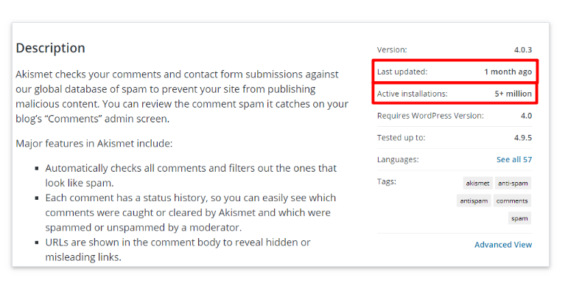

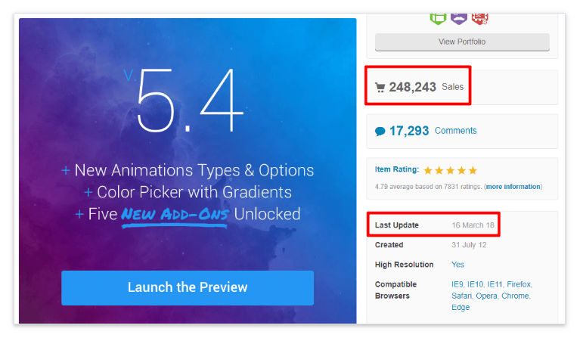

1. Check The Reviews:

* Check the plugins potential flaws by seeing the reviews of other users.
* Consult those reviewers before you pick a plugin.
* Both worpress.org and Envato make it easy to access third-party reviews.

1. How Responsive The Developer Is To Issues:

* Look the support forum in WordPress.org.
* It’s a good sign to see the developer is actively resolving support request or not.

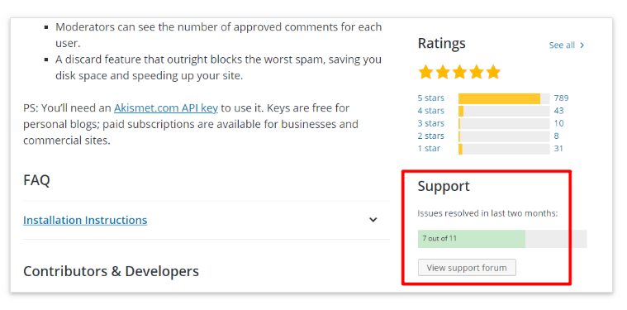

1. Don’t Use Nulled Plugins:

* Nulled plugins are a horrible idea, as they are with malware and vulnerabilities.

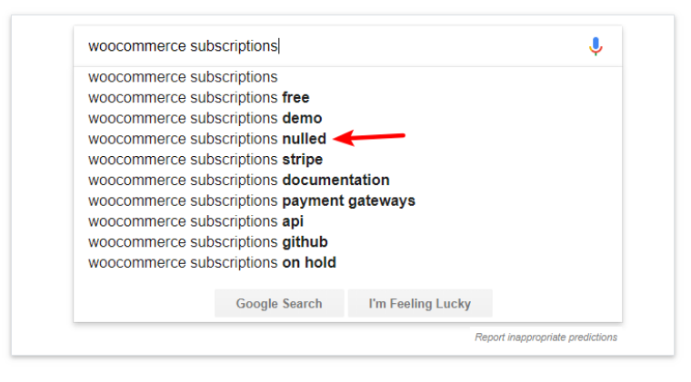

1. Use a Sandbox Tool Like Addendio to Test Plugins:

* Before installing it on your live (or staging site), go for a quick run in a sandbox tools like Addendio, oddly-named, poopy.life.
* Addendio lets you spin up a sandbox with the plugin already installed (if it’s listed at WordPress.org), while Poopy.life lets you create a blank sandbox where you’ll need to manually install the plugin yourself:

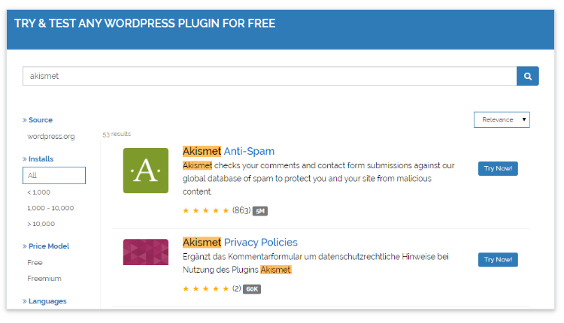

1. Use The P3 (Plugin Performance profiler) Plugin:

* This plugin focus on showing your site’s performance, as well as how individual’s plugins perform.

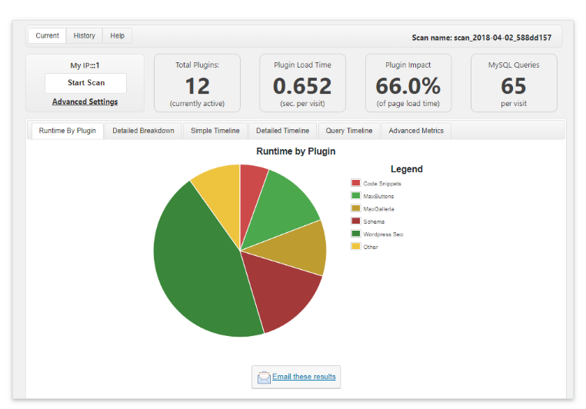

1. Read The Change Log To Check For Any likely Issues:

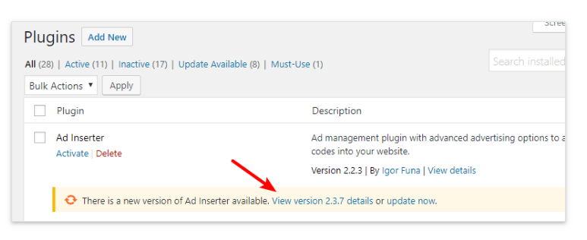

1. Use a Staging Site To Check For Compatibility Issues:

* A staging site is an awesome tool for testing plugins updates.
* Check the changelog and quickly run the relevant functionality on your staging site to make sure there aren’t any issues.

1. Don’t Leave Unused Plugins on Your Server:
2. 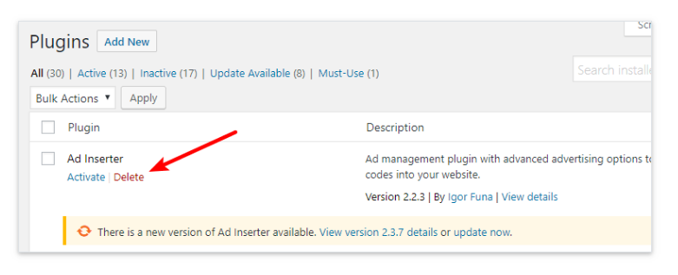 Remove Left-Behind Database Tables:

* Sometimes hitting Delete button does not remove all traces of a plugin from server db.
* If comfortable working with phpMyAdmin, one can remove tables manually.